**Lab – Join a Windows 10 Client to a Microsoft Domain**

**Overview**

In this lab, we will add our Windows 10 Professional VM to our freshly built Microsoft domain. We have a domain controller running DNS and DHCP server role has been installed. If our Windows 10 client can see itself as being on the same network as our domain controller, there should be no issues with joining the domain.

First some caveats about adding any device to a domain network. When we take any machine out of the box and drop said machine onto a new network, the machine must be able to see the network and find a DNS server before it will be able to join the domain.

The machine must first be configured with the correct TCP/IP information to be able to see the network where the DNS and domain controller reside.

In a previous lab, we installed DNS during the creation of our forest root, but we have not configured DHCP yet. Since or client cannot receive the TCP/IP information it needs dynamically, we will need to statically configure the client’s network adapter with the information it needs.

To begin, we click on the network icon located in the lower left corner of our Windows 10 desktop. We right click and select Open Network and Sharing Center.

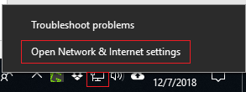

Once the Network and Sharing Center has opened, from the left-hand menu, 2X click on ‘Change adapter settings.’

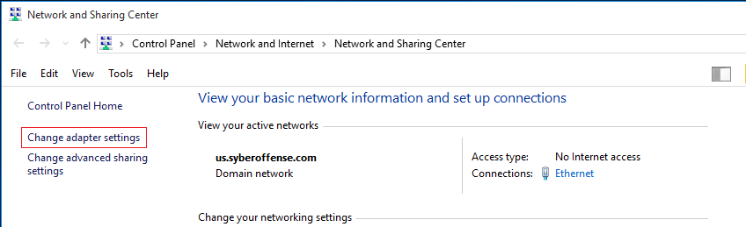

Find your Ethernet Connection, right click and from the content menu select properties.

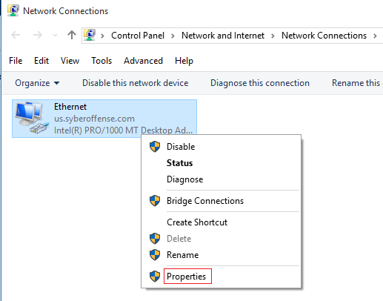

Under the Ethernet Properties, find the Internet Protocol Version 4 (TCP/IPv4) and either double click it or click on the properties button.

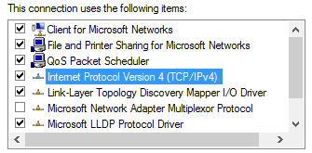

Here is where we statically configure our Windows 10 machine with all the IP address information it needs to communicate and join our Microsoft domain.

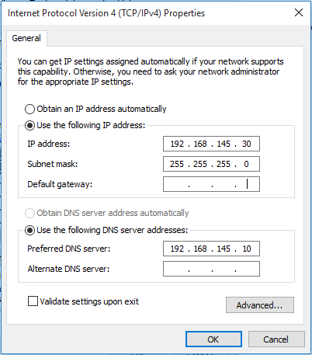

For this to work, I need to know what the network portion of my IP address is. The network porting is the first three octets of the full IP address (192.168.145.x). I next need to know what IP address I can assign to this workstation in the 4th octet of the machines IP address (x.x.x.30). I next need to know the IP address of the default getaway and the IP address of a DNS server located on the network. (for a full explanation of where I get this information, see the video tutorial for this lab.)

Once you have confirmed your Windows 10 network adapter TCP/IP settings are correct, click OK, close out any remaining dialog boxes and return to the desktop.

Now would be a good time to confirm your Windows 10 machine can communicate with your Windows server. We can do this by just conducting a quick and simple PING test. We ping the network IP address assigned to the domain controller.

Click on the start menu and in the search window, type cmd. Select the command prompt from the search options.

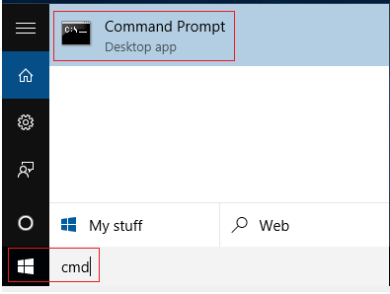

At the command prompt, type the word ping followed by the network IP address for your domain controller. In this example, I’m pinging 192.168.145.10 as this is the network IP assigned to my DC1.

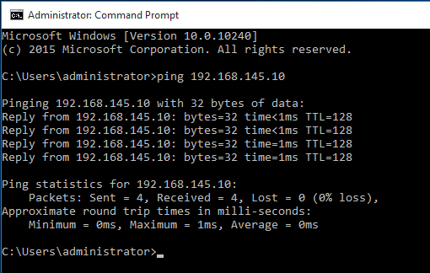

If you get back four good responses, you are ready to join your Windows 10 machine to the network. If not, ensure both your machines are using the same host-only adapter settings for VirtualBox or VMWare. Next, check the IP address configuration on both your server and your client. Keep troubleshooting and pinging until you get a positive response.

Once we have confirmed network connectivity, we can move on to joining the machine to the domain. From your Windows 10 client, click on the start button and from the start menu, click on Control Panel and from the pop-out menu, select System.

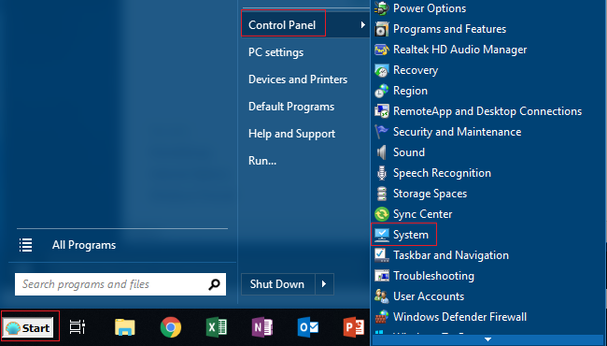

In the lower left of the System dialog box, find and click the Change settings button.

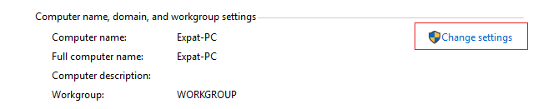

When the system properties page opens, click on the Change button.

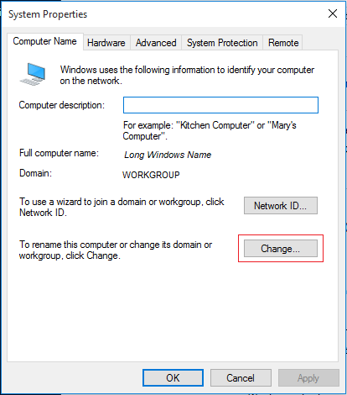

From here you can change your Computers Name to a more user-friendly name. Select the radio button for **Domain**. The text box now becomes available.

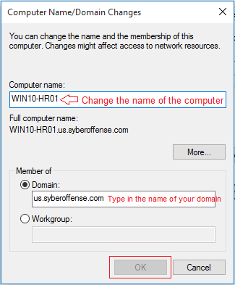

Type in the name of your domain, in this example we’re using us.syberoffense.com but the name of your domain may differ. You might be able to get away with just using your shortened NETBIOS name but if that fails, type in the full name of your domain.

When you click ok, you will be asked for the domain administrator’s username and password. Only a member of the Domain Administrator’s group can add and remove machines from the network. This is the username and password you use to log onto your Server 2012 or 2016 domain controller.

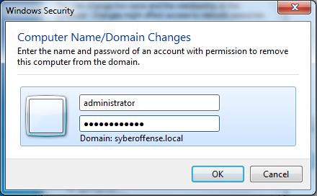

If you specified the correct credentials, you will be welcomed to the Domain. Click OK. Restart when prompted for the changes to take effect.

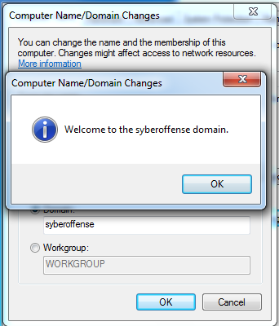

If your machine has joined the domain successfully, you are a go with this portion of the lab.

This procedure for joining a Microsoft client or Windows Server (2000, 2003, 2008, 2012, 2016 or 2019) to a Microsoft domain, has not changed in the last 15 years. Regardless of the machine, if you configure the TCP/IP properties correctly, it should be able to join the domain without an issue but, **no machine can join a domain until you have the machine sitting on the same network and able to communicate with a domain controller.**

When your machine comes back up after the restart, send a CTRL+ALT+DELETE to login.

Click the icon for the **Other User**

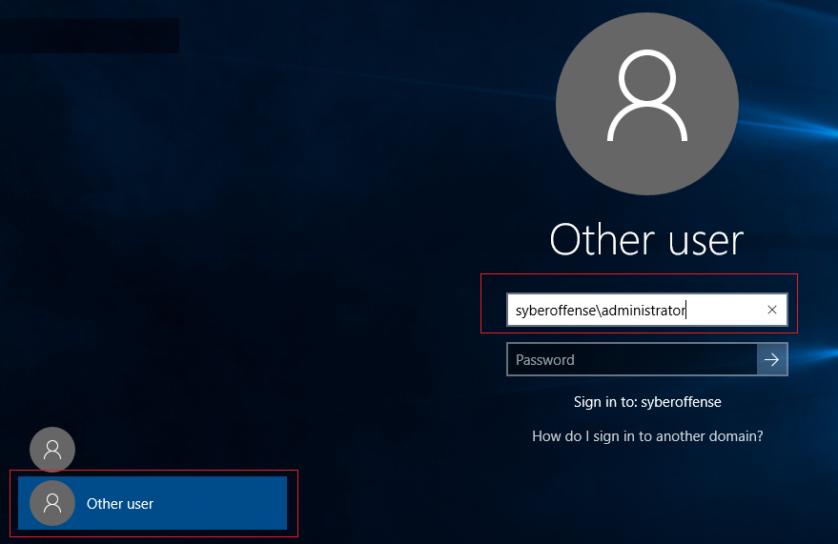

You need to log the machine onto the domain. To do this we use **domain name\administer** for our logon name and we use the domain administrator password for the password.

Let’s find our new machine inside of Active Directory.

Log onto your Server 2012 or 2016 domain controller.

From your Server Manager console, click on Tools and from the available snap-ins, select Active Directory Users and Computers.

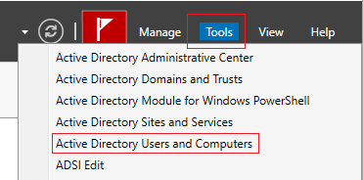

Once the ADUC opens, click on your domain name and open the Computers OU. In the right windows pain, you see the computers that are members of your domain.

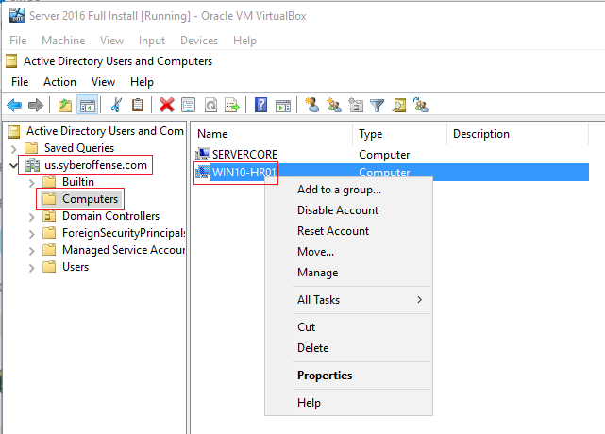

Right-click on the name of your Windows 10 machine. Here you see all the options you have for dealing with a computer in AD. Select properties.

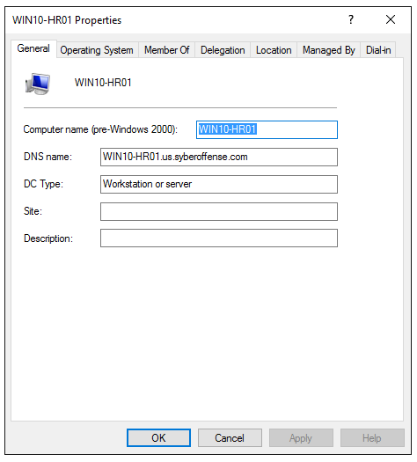

You can click through the tabs and see what options you have for managing your machines in a Microsoft domain.

**Summary**

The way we design our Active Directory has a huge impact on how well we manage it. Keep it simple and keep it clean. Do it right the first time and years from now; the design will still be effective as the day you built the network.

End of the lab!